

Year 12
ATAR
Human Biology

Name:
ANSWERS
Teacher:

Task 1: Science Inquiry Skills Test |  |  | Weighting 5%
Marks Received | Marks Available | Percentage
30 | 30 | 100%

Time Allocated:
Reading time: 5 minutes
Working time: 50 minutes

Use the following information to answer question 1-9.

Human erythrocytes contain the pigment haemoglobin which gives blood its red colour. Normally haemoglobin cannot pass out of the cell. A group of research scientists conducted experiments investigating the effect of different treatments on the structure of the cell membrane. In one experiment, scientists placed samples of blood into several test tubes. To each test tube they added a saline solution that had the same concentration of water and salts as plasma. The red blood cells formed a layer on the bottom and the saline solution was clear. The effect that the treatment had on the structure of the cell membrane was determined by measuring the concentration of haemoglobin in the saline solution. Undamaged cells would not release haemoglobin. The test tubes were placed into water baths on which the temperature could be regulated. Some of the test tubes were kept at 37ºC, others were kept at 40ºC, 45ºC, 50ºC, 60ºC and 70ºC. After a period of time the haemoglobin concentration in the saline solution in each test tube was measured. The average concentration of haemoglobin in the test tubes kept at each temperature was recorded. The table below shows the results.
Table 1: The effect of temperature on the cell membrane of erythrocytes
Temperature of test tube (ºC) | Average concentration of haemoglobin in the saline solution : ppm (parts per million)
37 | 0.0
40 | 0.0
43 | 0.0
45 | 5.5
50 | 12.5
60 | 22.0
70 | 22.0

1. Write a hypothesis for this experiment?
If the temperature increases then the concentration of haemoglobin will increase. (2 marks)

2. Identify the independent and dependant variables in this investigation.

Independent: Temperature
Dependent: Concentration of haemoglobin (2 marks)

3. Identify four control variables in either the method or equipment used in the investigation.

Amount of red blood cells places in test tube
Volume of saline solution in each test tube
Size of test tubes
Time that test tubes were in the water bath
*Any other reasonable suggestion.
*Must describe not list factors

(4 marks)

4 Plot the data below.
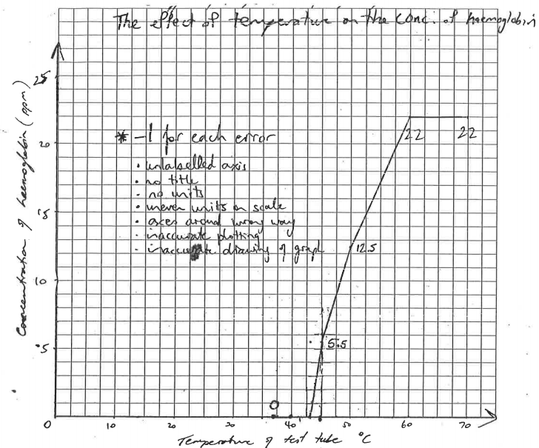(5 marks)

5. Using your graph, predict the concentration of haemoglobin in the saline solution at 55ºC.

17-17.9 ppm (depending on graph) (1 mark)

6. Describe the trends shown in the graph.

Concentration increases after 43 degrees
Increases up to 60 degrees and levels off.
(2 marks)

7. Was your hypothesis supported? Explain.
Yes. There is a correlation between temperature and concentration between 43 and 60 degrees.
(1 mark)

8. Why were test tubes kept at 37ºC included in this experiment?
It’s a control-to see if temperature makes a a difference
Normal body temperature
(2 marks)

9. How could you ensure the reliability of your results if you were conducting this experiment?
Repeated the experiment
Replicated each test tube
(2 marks)

Use the following information to answer question 10-11.

Another group of scientists were investigating the effect of different kinds of toxins on the receptor proteins in the cell membrane. In one experiment they were trying to determine how different concentrations of toxin found in spider venom affected the ability of liver cells to take up glucose from the blood. Under normal conditions the hormone insulin binds to particular receptor proteins in the cell membrane of liver cells causing them to absorb glucose form the blood. The scientists believed that the toxin blocked the receptor proteins, preventing insulin from binding to them, and as a result stopping the absorption of glucose. In their experiment they set up three flasks with different amounts of liver cells in them. The cells were in a solution that kept them alive for 12 hours. Each flask was set up as follows:

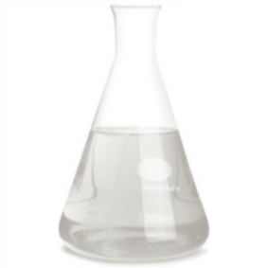
Flask 1 Flask 2 Flask 3
20 mL liver cell solution 40 mL liver cell solution 60 mL liver cell solution

100 mL glucose solution 200 mL glucose solution 300 mL glucose solution

Kept at 37ºC Kept at 40ºC Kept at 25ºC

0.1% toxin 0.5% toxin 1.0% toxin

10 mL of insulin solution 20 mL of insulin solution 30 mL of insulin solution

After 6 hours the concentration of glucose in each flask was measured.

- What is the independent variable? Explain why measuring the concentration of glucose in each flask after 12 hours would be a suitable way of determining the effect of the independent variable.
Toxin concentration
Toxins prevent cells from absorbing glucose
The higher the concentration, the smaller the amount absorbed
(3 marks)

- There are several significant problems with the design of this experiment that affect both its validity and reliability. Describe changes you would make to improve this experiment.

Validity | Reliability
Same amount of liver cells/liver cell solution in each flask | Use several flasks for each toxin concentration
Same amount of glucose solution in each flask | Repeat the experiment several times
Same amount of insulin solution in each flask | Use accurate measuring methods/equipment for glucose concentration
All flask kept at 37 degrees
All flasks same size
Use a control flask with no toxin

*At least 2 examples from each side.
(6 marks)

